Lab Report – 2

ECS 330 : Experiment: Filter Design

Name: Ajay Choudhury (18018) Date of Submission: 27th January 2021

Solutions

Q.1. Solution

**Code:**

1. syms t w;
2. f1 = 20;
3. f2 = 40;
4. f3 = 60;
5. x = cos(2*pi*f1*t) + cos(2*pi*f2*t) + cos(2*pi*f3*t);
6. ft = fourier(x, t, w)

**Output:**

1. ft = pi*(dirac(w - 40*pi) + dirac(w + 40*pi)) + pi*(dirac(w - 80*pi) + dirac(w + 80*pi)) + pi*(dirac(w - 120*pi) + dirac(w + 120*pi))

Q.2. Solution

**Code:**

1. [b , a] = butter (4, 40, ‘s’);
2. wband = logspace(-20, 40);
3. freqs(b, a, wband);

**Figure:** (On Next Page)

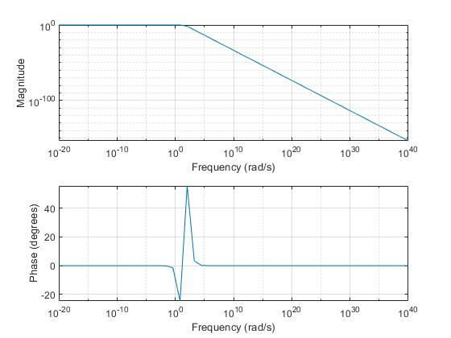

Q.3. Solution

**Code:**

1. [b , a] = butter (4, 40, ‘s’);
2. wband = logspace(-20, 40);
3. freqs(b, a, wband);
5. H(w) = poly2sym(b, w) / poly2sym(a, w)

**Output:**

1. H(w) = 2560000/(w^4 + (3677647801095837*w^3)/35184372088832 + (1501587004615895*w^2)/274877906944 + (718290586151531*w)/4294967296 + 2560000)

**Figure:**



Q.4. Solution

**Code:**

1. Y(w) = H(w).*ft;
2. y(t) = ifourier(Y,w,t);

**Output:**

1. y(t) = ((4398046511104000*pi*exp(-pi*t*80i))/(70368744177664000*pi^4 - 91941195027395925*pi^3 + 60063480184635800*pi^2 - 22985298756848992*pi + 4398046511104000) + (4398046511104000*pi*exp(pi*t*80i))/(70368744177664000*pi^4 + 91941195027395925*pi^3 + 60063480184635800*pi^2 + 22985298756848992*pi + 4398046511104000) + (35184372088832000*pi*exp(-pi*t*40i))/(35184372088832000*pi^4 - 91941195027395925*pi^3 + 120126960369271600*pi^2 - 91941195027395968*pi + 35184372088832000) + (35184372088832000*pi*exp(pi*t*40i))/(35184372088832000*pi^4 + 91941195027395925*pi^3 + 120126960369271600*pi^2 + 91941195027395968*pi + 35184372088832000) + (35184372088832000*pi*exp(-pi*t*120i))/(2849934139195392000*pi^4 - 2482412265739689975*pi^3 + 1081142643323444400*pi^2 - 275823585082187904*pi + 35184372088832000) + (35184372088832000*pi*exp(pi*t*120i))/(2849934139195392000*pi^4 + 2482412265739689975*pi^3 + 1081142643323444400*pi^2 + 275823585082187904*pi + 35184372088832000))/(2*pi)

Q.5. Solution

**Code:**

1. fs = 1000;
2. t1 = 0:1/fs:2-1/fs;
3. x_numeric = double(subs(x,t,t1));
4. y_numeric = double(subs(y,t,t1));
5. figure
6. subplot(2,1,1)
7. plot(t1,x_numeric)
8. subplot(2,1,2)
9. plot(t1,y_numeric)
10. ylim=[-4,4];
11. Y_NUM=fft(y_numeric);
12. X_NUM=fft(x_numeric);
13. n=length(X_NUM);
14. f=(0:n-1)*fs/n;
15. figure;
16. subplot(2,1,1);
17. plot(f(1:floor(length(X_NUM)/2)), abs(X_NUM(1:floor(length(X_NUM)/2))));
18. xlabel('\textbf{Frequency (Hz)}', 'Interpreter', 'latex');
19. ylabel('\textbf{Magnitude}', 'Interpreter', 'latex');
20. grid;
21. subplot(2,1,2);
23. plot(f(1:floor(length(Y_NUM)/2)), abs(Y_NUM(1:floor(length(Y_NUM)/2))));
24. xlabel('\textbf{Frequency (Hz)}', 'Interpreter', 'latex');
25. ylabel('\textbf{Magnitude}', 'Interpreter', 'latex');
26. grid;

**Figures:**

